New Parishioner

Welcome Pack

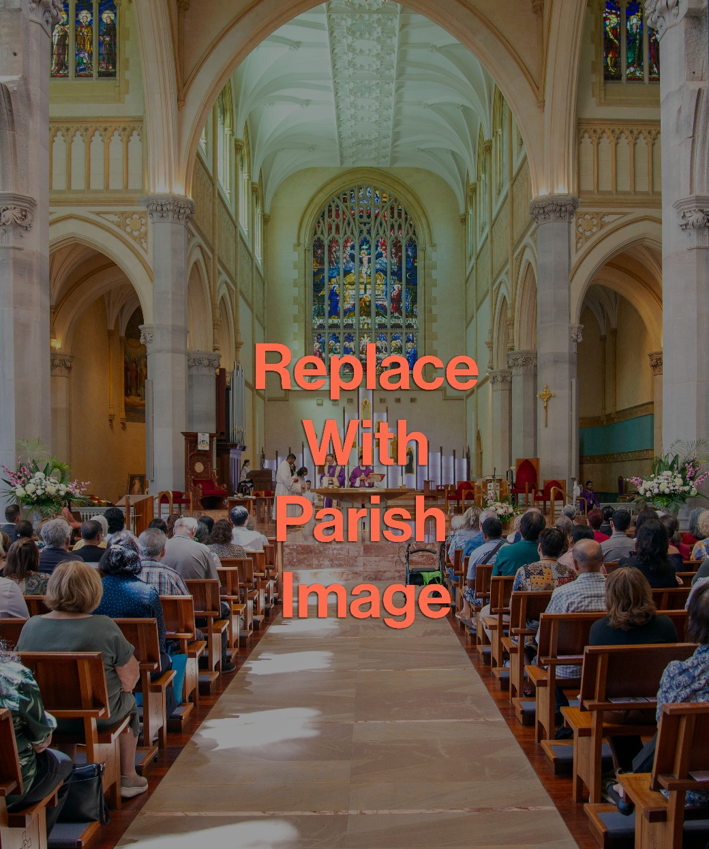

All of you are Christ’s body,
and each one is a part of it.
1 Corinthians 12:27


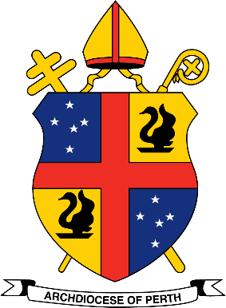

The Catholic Archdiocese of Perth

Our Mission
To give expression to a Christ-centred, faithful, vibrant, welcoming, inclusive and mission-orientated Church,
one which will enrich our own lives and the lives
of all who we encounter and seek to serve.

Our Vision
We see ourselves, and conduct ourselves,
as people called to walk together
in the footsteps of the Good Shepherd.

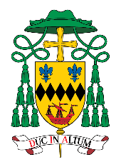
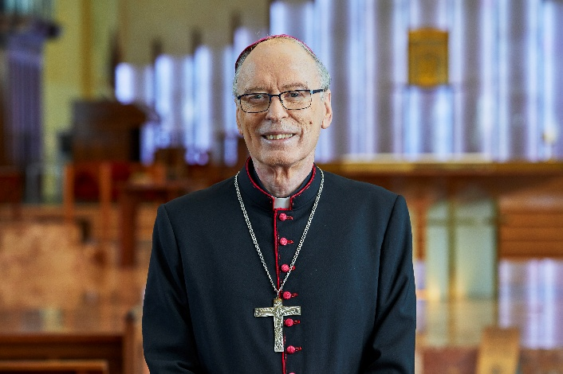

A Warm Welcome to Our Parish Community

It is a pleasure to offer you this Parish Welcome Pack as a sign of the Church’s desire to walk with you in faith, hope, and belonging.
At the heart of every parish is the call to be a community of encounter - where each person is received with openness, where faith is nurtured, and where Christ’s love is made visible through prayer, service, and fellowship. This resource has been prepared to help you become familiar with parish life, to discover opportunities for involvement, and to know that you have a valued place within the community.
May this Parish Welcome Pack be a helpful introduction to your parish and a gentle invitation to deeper connection with the community. May you feel supported, respected, and encouraged as you grow in your relationship with Christ and one another, and may you find in your parish a true spiritual home.
Yours in Christ



+ Most Rev Donald Sproxton
AUXILIARY BISHOP OF PERTH



We are delighted to welcome you to our parish. Whether you are new to the area, returning to the Church, or simply seeking a deeper relationship with Christ, we are here to support and walk with you on your faith journey. We invite you to be part of our parish family, grow in faith, and share in the love of Christ.

This welcome pack will introduce you to the life of our parish and help you get involved in our community. We hope it serves as a helpful guide as you settle into your new spiritual home.

1. Welcome Letter from the Parish Priest
Dear Click or tap here to enter text.,
On behalf of the entire parish community, I extend a warm and heartfelt welcome to you. We are so grateful that you have chosen to join us in worship and fellowship, and we are thrilled to have you as part of our parish family.
As Catholics, we are called to walk together in faith, and it brings me great joy to know that you are now a part of our community. Our parish is a place of prayer, support, and spiritual growth, and I encourage you to get involved as you feel called. Whether you join a ministry, attend a study group, or participate in our outreach programs, there are countless opportunities to build meaningful connections and deepen your relationship with God.
We are here to help you grow in faith and live out the Gospel message. I pray that you find peace, joy, and a sense of belonging within our parish community.
Once again, welcome, and may God bless you abundantly.
In Christ,
Click or tap here to enter text.

Parish Priest

Click or tap here to enter text.
- Parish Vision
Click or tap here to enter text.

- Parish Mission
Click or tap here to enter text.

Safeguarding
Our parish community promotes the inherent dignity and safety of all persons.
We take a zero-tolerance approach to child abuse and the abuse of adults at risk.
We recognise that safeguarding is everyone’s responsibility and we are committed to fostering a culture and environment of safety and care.
We are fully committed to the Safeguarding Program and its Code of Conduct. Please
refer to the following links:

SAFEGUARDING POLICY CODE OF CONDUCT SAFEGUARDING GUIDELINES

Inclusive Community
This parish is committed to building an inclusive community.
An inclusive Catholic parish reflects the universal nature of the Church by embracing all people as part of the Body of Christ. By creating a welcoming environment, offering culturally and physically accessible worship, and ensuring that all parishioners have a place in leadership and ministry, the parish can truly embody Christ’s love for all.

Parish Information
  - Parish Name & Address: Click or tap here to enter text.
  - Website: Click or tap here to enter text.
  - Social Media Handles: Click or tap here to enter text.
  - Email & Phone Number: Click or tap here to enter text.
  - Office Hours: Click or tap here to enter text.
  - Pastoral Team: Click or tap here to enter text.
  - Safeguarding Officers: Click or tap here to enter text.
  - Parish Pastoral Council: Click or tap here to enter text.
  - Parish Finance Council: Click or tap here to enter text.

Mass & Reconciliation Schedule
- Weekend Masses: Click or tap here to enter text.
- Weekday Masses: Click or tap here to enter text.
- Reconciliation Times: Click or tap here to enter text. or by appointment
- Adoration: Click or tap here to enter text.

Ministries & Groups
A brief overview of ministries and opportunities to get involved with our parish, such as:
  - Liturgical Ministries (Readers, Acolytes, Eucharistic Ministers, Altar Servers, Liturgy Committee, Choir, Flowers, Ushers etc)
  - Faith Formation (Bible Study, RCIA, Children’s liturgy etc)
  - Prayer & Devotional Groups
  - Community Outreach (Personal Advocacy Service, Catholic Outreach, St Vincent de Paul, The Shopfront, Social Justice etc)
  - Youth / Young Adult / Men / Women Groups
Click or tap here to enter text.

Sacraments & Rites
Information on how to receive the sacraments, including:
  - Baptism
  - First Communion
  - Confirmation
  - Marriage
  - Anointing of the Sick
  - Funeral Rite

Upcoming Events & Bulletin
  - For information about upcoming parish events, retreats, and special Masses view our weekly bulletin here
Click or tap here to enter text.

  - For all the latest news from the archdiocese, subscribe to The Record.

Stewardship & Giving
- Volunteer opportunities
- How to support the parish financially (Planned Giving, EFTPOS tap and go,
direct debit
Click or tap here to enter text.

List of Services Available in the Parish
Schools, hospitals, aged care, medical centres, mental health services, community
facilities, multicultural hubs etc.

Click or tap here to enter text.

List of Archdiocesan Agencies & Offices with Contact Details
13.1ABORIGINAL CATHOLIC MINISTRY (Contact: Donella Brown)
https://acm.perthcatholic.org.au/

13.2 CATHOLIC BIOETHICS CENTRE (Contact: Fr Joe Parkinson)
https://www.bioethicsperth.org.au/

13.3 CATHOLIC OUTREACH (Contact: Marietta Russo )
https://outreach.perthcatholic.org.au/

13.4 CATHOLIC YOUTH MINISTRY (Contact: Adam Phillips )
https://cym.com.au/

13.5CENTRE FOR CATHOLIC FAMILY & JUSTICE SUPPORT SERVICES
(Contact: Adrian Martino)

Website TBA
Centre for Life Marriage and Family
Justice, Ecology and Development Office
Catholic Social Services Western Australia
Catholic Prison Ministry

13.6 CENTRE FOR CHRISTIAN INITIATION & LITURGY (Contact: Dr Carmel Suart)
https://initiation.perthcatholic.org.au/
https://liturgy.perthcatholic.org.au/

13.7 CENTRE FOR FAITH ENRICHMENT (Contact: Dr Marco Ceccarelli )
https://cfe.org.au/

13.8 DAYDAWN ADVOCACY CENTRE (Contact: Mark Reidy)
https://daydawn.perthcatholic.org.au/

13.9 PERSONAL ADVOCACY SERVICE (Contact: Margie Tannock)
https://pas.perthcatholic.org.au/
Emmanuel Centre
Catholic Deaf and Hearing Impaired Ministry

13.10 STELLA MARIS SEAFARERS CENTRE (Contact: Claude Coutinho)
https://stellamaris.perthcatholic.org.au/

13.11 THE SHOPFRONT (Contact: Damian Walsh)
https://shopfront.perthcatholic.org.au/
13.12 WA CATHOLIC MIGRANT & REFUGEE OFFICE (Contact: Dcn Greg Lowe)
https://wacmro.perthcatholic.org.au/
13.13 OFFICE of COMMUNICATIONS (Contact: Jamie O’Brien)

Support & Emergency Contact Numbers
Beyond Blue, Lifeline, 1800 Respect etc.

Click or tap here to enter text.

Join Us in Building Our Faith Community.
We look forward to getting to know you. Please feel free to introduce yourself after Mass or stop by the parish office. If you have any questions or need assistance, don’t hesitate to reach out.

God bless you, and welcome!

Click or tap here to enter text.

Click or tap here to enter text.

A Note for the Parish Priest / Secretary

Parish Registration Form
A simple form for the newcomer to officially register as a parishioner, ensuring they receive parish updates and sacramental preparation information. (See attachment)s

Survey (or Parish Registration Form and Survey combined?)
Questions about the needs of the parishioner to understand how the parish may help them. (See New Parishioner Needs Survey)

Small Gift (Optional)
A small token of welcome, such as a blessed parish prayer card, parish saint card or rosary.

The following appendix provides a sample survey for identifying the needs of new parishioners. It should be adapted to suit the specific requirements of the parish.

Appendix
NEW PARISHIONER NEEDS SURVEY
Thank you for joining our parish family. We are committed to creating an inclusive, welcoming, and supportive environment for all our parishioners. Please take a few moments to complete this survey to help us understand your needs. Your responses will be kept confidential.

Personal Details
  - Family Name: Click or tap here to enter text.First Name: Click or tap here to enter text.
  - Email Address: Click or tap here to enter text.
  - Phone Number: Click or tap here to enter text.
  - Preferred Language: Click or tap here to enter text.
  - Are you a member of any specific cultural or ethnic group of which you would like us to be aware? (Optional) Click or tap here to enter text.

Faith Needs

How long have you been attending Mass at our parish?
☐Less than 1 month
☐ 1-3 months
☐ 4-6 months
☐ More than 6 months

What are you looking for in your faith journey here at the parish? (Tick all that apply)
☐ Mass & Sacraments
☐ Faith formation classes (Bible study, Christian meditation, Rite of Christian
Initiation of Adults, Lenten and Advent programs, etc.)
☐ Retreats
☐ Opportunities for prayer and reflection
☐ Support in times of change, loss and grief
☐ Fellowship

Are there any specific areas of your faith journey where you would like
additional support or guidance? (Optional)
Click or tap here to enter text.

Physical & Accessibility Needs
We strive to ensure that our parish is accessible to everyone. Please let us know if you have any physical or mobility challenges with which we can assist.

Do you or any household member require any physical supports to fully participate in parish activities?
☐ Yes
☐ No

If yes, please tick any physical supports you or a household member may need:
☐ ACROD or Priority Parking
☐ Wheelchair access
☐ Accessible seating
☐ Assistance with mobility (e.g. walking aid, wheelchair)
☐ Hearing assistance (e.g. hearing audio loop, Auslan interpreted Gospels)
☐ Large-print materials
☐ Other (please specify): Click or tap here to enter text.

Well-being
We care for the well-being our parishioners. Please let us know if there are any ways we can support you.

Do you have any well-being concerns of which you would like the parish to be aware?
☐ Yes
☐ No

If yes, please tick any of the following that apply:
☐ Support during times of grief (bereavement, other changes/losses)
☐ Counselling or spiritual direction
☐ Family pastoral matters
☐ Support for life transitions
☐ Other (please specify): Click or tap here to enter text.

Family Needs
Our parish supports all age groups. Please let us know how we can best serve your family/household.

Do you have children or dependents in your care?
☐ Yes
☐ No

If yes, please indicate their ages:
☐ Infant to 5 years
☐ 6 to 12 years
☐ 13 to 18 years

Are you interested in any of the following for your children and/or young people?
☐ Sacrament preparation
☐ Religious education
☐ Youth ministry
☐ Family-centred activities
☐ Parenting support
☐ Children’s Liturgy

Do you have any family/household members requiring visitation?
☐ Home
☐ Hospital
☐ Aged Care
☐ Holy Communion

Social & Cultural Inclusion
We are committed to ensuring that parishioners feel welcomed, respected, and valued.

Do you feel comfortable and welcomed by our parish community?
☐ Yes
☐ No
☐ Somewhat

Are there cultural or social activities you would like to see incorporated into parish life? (Optional)
Click or tap here to enter text.

Are there specific customs or traditions you would like us to be mindful of during
parish activities? (Optional)
Click or tap here to enter text.

Volunteer & Engagement Opportunities
We encourage our parishioners to be actively involved in the life of the parish and diocese. Please let us know if you are interested in volunteering.

Would you be interested in volunteering in any of the following ministries?
☐ Parish Pastoral Council
☐ Liturgical ministries (e.g. lectors, Extraordinary Minister of Holy Communion,
Acolyte, Senior Altar Minister)
☐ Safeguarding
☐ Social outreach and service (e.g. The Shopfront, St Vincent de Paul, Parish
Pastoral Care Program - Catholic Outreach)
☐ Youth ministry or children’s programs
☐ Music ministry
☐ Administrative help (e.g. office work, communication)
☐ Hospitality (e.g. greeter, catering and serving at parish events)
☐ Other (please specify):
Click or tap here to enter text.

Additional Comments & Suggestions
Is there anything else you would like us to know or any specific ways we can better serve you?

Click or tap here to enter text.

Thank you for taking the time to complete this survey.
Your responses will help us ensure that our parish is a welcoming and supportive community for all. Please return the completed survey to the parish office or email it to
Click or tap here to enter text.

We look forward to journeying with you in faith and celebrating the gifts and talents you bring to our parish community.

Notes

Click or tap here to enter text.

